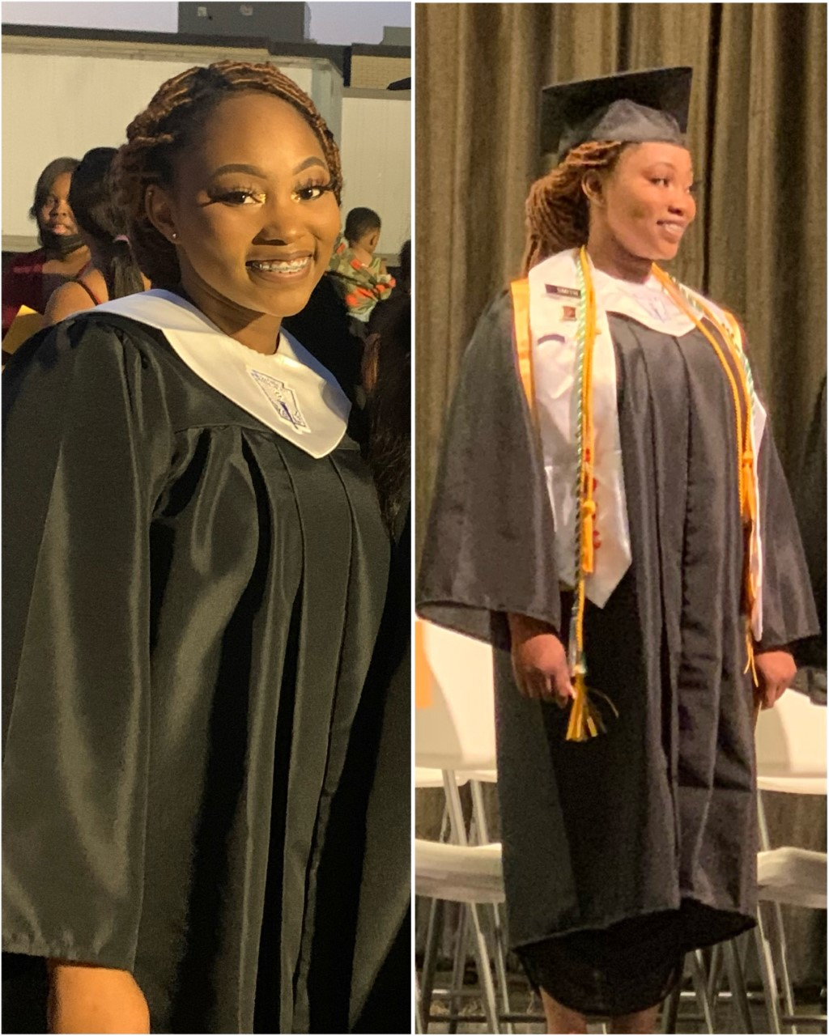
NCF 2022 Scholarship Winners

Bogalusa Scholarship to support a Bogalusa High School senior attending a 4-year college/university.
- Miss Elexzandra Smith the Vice President of the Senior Beta Club, member of the National Honor Society, Public Affairs Officer of the JROTC, member of the Flag Team and has represented Bogalusa High School at the District Literary Rally. She plans to attend the University of Southern Mississippi in the fall majoring in biological science focusing on pre-med.

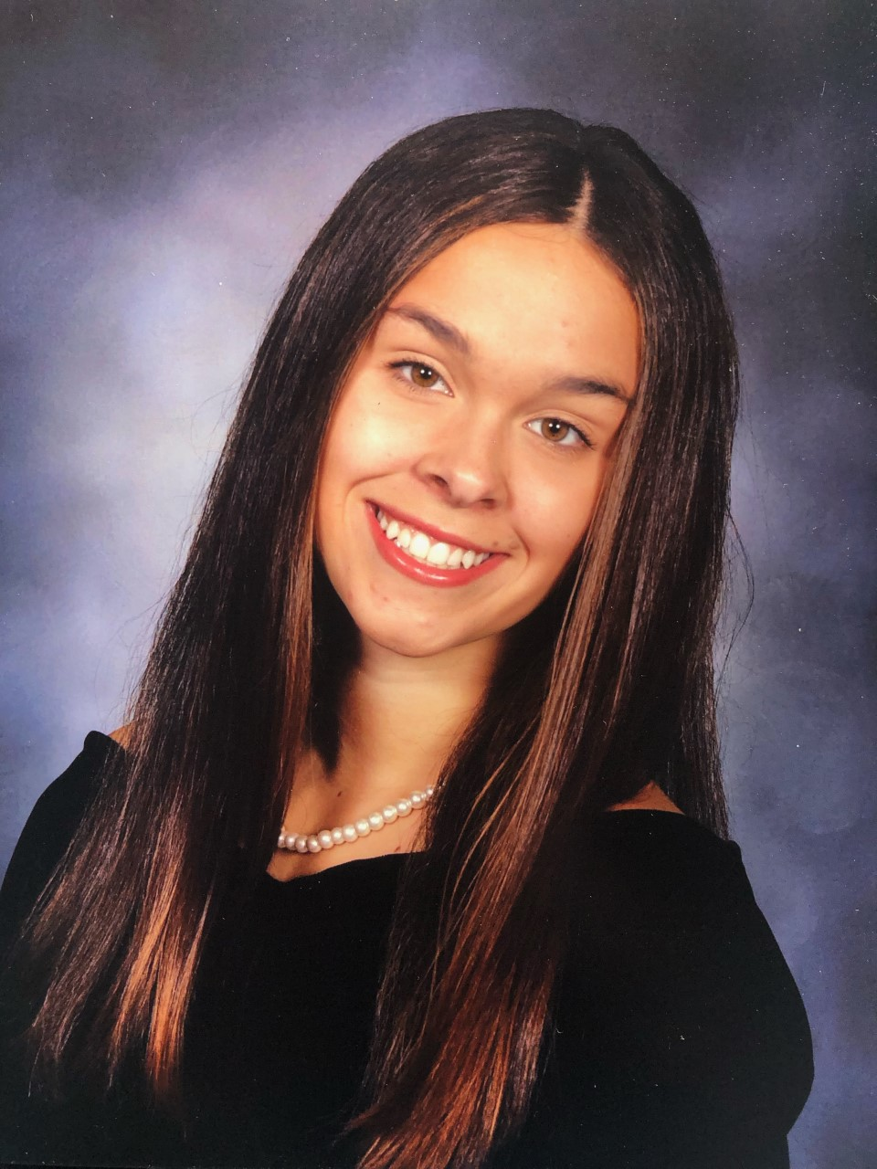
Summers Legacy Foundation Scholarship to support a graduating senior residing in St. Tammany Parish planning to attend an out of state college/university.
- Miss Madelyn Kriesen graduating senior from Archbishop Hannan High School. She is the President of the National Honor Society, Captain of the Swim Team a member of the Student Council, Spanish Honor Society, Science National Honor Society, Mu Alpha Theta, and Debate team. She plans to attend the University of Florida in the fall to pursue a degree in biomedical engineering.

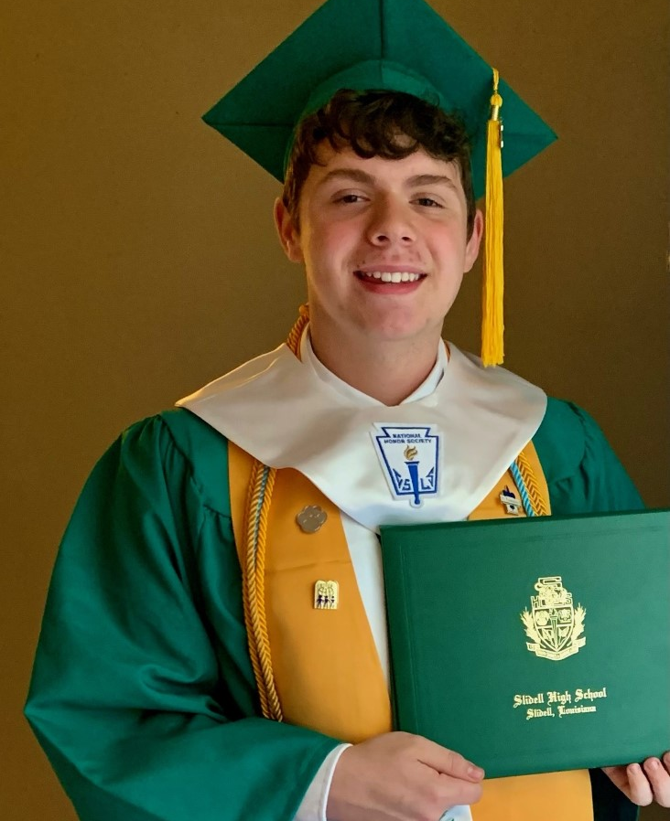
Greg Zelden Scholarship to support graduating seniors and undergraduate students residing in St. Tammany, Tangipahoa and Washington Parishes attending a college/university seeking a career in Allied Health and/or Sports Medicine.
- Mr. Connor Meyers graduating senior from Slidell High School. Mr. Meyers is a member of the National Honor Society, Mu Alpha Theta, NJROTC and Theatre. He has plans to attend Southeastern Louisiana University in the fall to pursue a degree in science and public health.

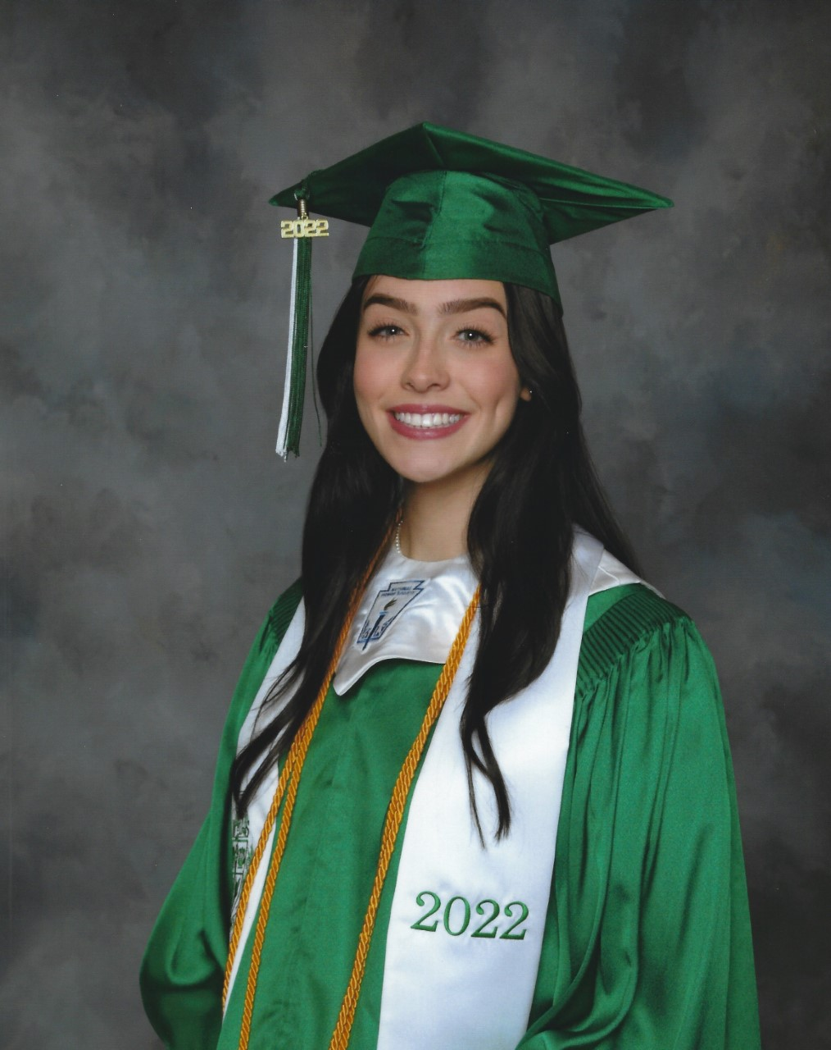
Donna Kahl Manetta Scholarship to support a graduating senior of Slidell High School who has demonstrated a record of high academic achievement and outstanding service to the school and the surrounding community.
- Miss Madeline Gilley graduating senior from Slidell High School. Miss Gilley is the Vice President of the Beta Club a member of the National Honor Society, Mu Alpha Beta, History Club, Film Club, Cross Country, and Track teams. She plans to attend Louisiana State University in the fall.

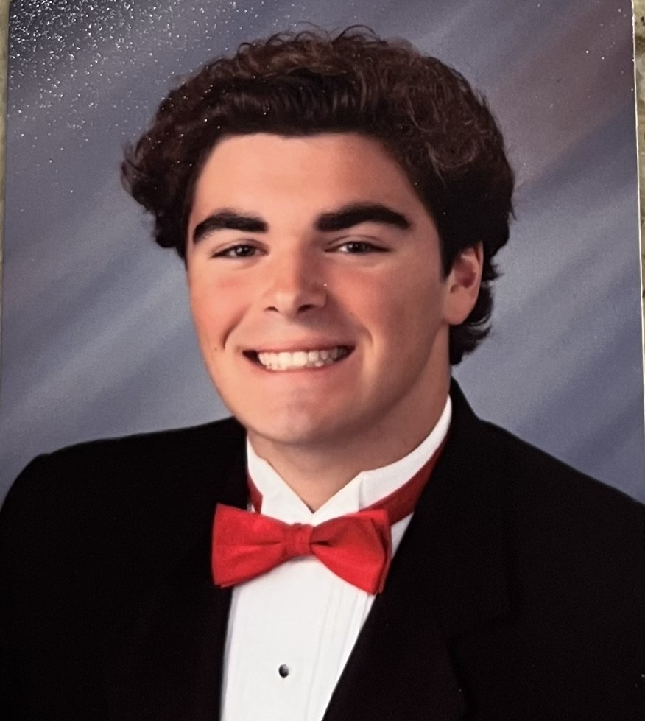
South Slidell Swimming Scholarship to support a high school senior(s) who participated in either the Salmen High School Swim Team or the Lakeside Gators Swim Team.
- Mr. Dominick Montecino graduating senior from Brother Martin High School who swam for the Lakeside Gator’s Swim team. Mr. Montecino Is a member of the National Honor Society and Mu Alpha Theta. He is a member of the USA swim team a competitive swim team and plans to attend Great Lakes Maritime Academy to pursue a career in the Maritime Industry.

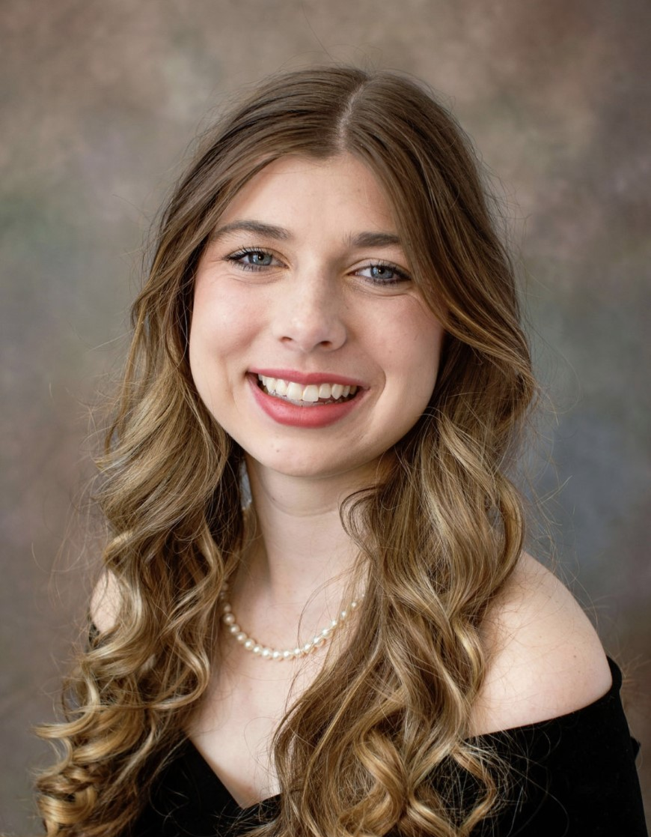
Notes for Education Northshore Scholarship to support a high school senior attending a public college/university to pursue a degree in either music performance or music education.
- Miss Elise Strain graduating senior from Fontainebleau High School is a member of the National Honor Society, co-President of the Mock Trial Team, a member of the Spark Club, and the Bulldog Buddies. She is a 2021 Louisiana Music Educators Association All-State Choir performer. Miss Strain plans to attend Baylor University in the fall where is she accepted into to the Bachelor of Music/Performance degree program for voice.

Tulane Legislative Scholarship (Representative Mark Wright-District 77)
- Miss Bela Menon graduating senior from Christ Episcopal School is the Vice President of the Student Council, Vice President of the Bio-Medical Sciences Club, and member of the National Honor Society and Key Club. She will major in Neuroscience with plans to attend medical school.

11 Scholarships renewed-mid process:
- 9 St. Tammany Cancer Scholarships
- 2 Tulane Legislative Scholarships:
  - Senator Sharon Hewitt awarded through 2025
  - Senator Patrick McMath awarded through 2024

