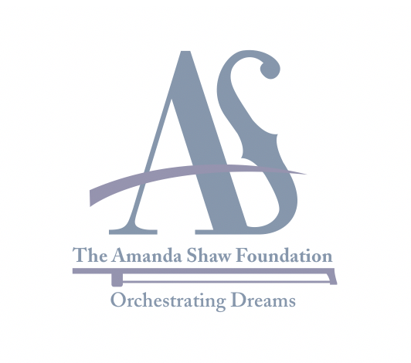

THE AMANDA SHAW FOUNDATION ORCHESTRATING DREAMS FUND

History and Purpose: The Amanda Shaw Foundation Orchestrating Dreams Fund was created in collaboration with the Northshore Community Foundation to provide scholarships to young people to support their passions and fulfill their dreams. The scholarship will assist school-aged children to facilitate or offset cost associated with developmental and/or educational programs and creative events. The goal of the Fund is to foster, build, sustain and empower strong Louisiana families through music, food and culture. The purpose of this scholarship is not to be used to support traditional college tuition.

Eligibility Criteria:
- Resident of Louisiana;
- Students ages 10 through 18 who are currently enrolled at any public, parochial/private, and charter school in Louisiana;
- Financial Need consideration;
- Students who are interested or are participating in a development and/or educational program and/or creative event;
Selection Criteria:
- Grade Point Average minimum of 2.5;
- Demonstrated interest in or commitment to music, food and/or cultural programs;
- Demonstrated Creativity if applicable

Award: The minimum scholarship award amount is $500. However, award amounts may exceed this amount. Total scholarship award is up to the discretion of the Selection Committee and Board of Directors. Number of recipients will be determined annually. Scholarship cycle is open year-round. A one-time scholarship will be awarded to selected students. Once a student is awarded the scholarship, he/she will not qualify for another fund award for the next three years. The award check will be made payable to the organization/program, not the individual.

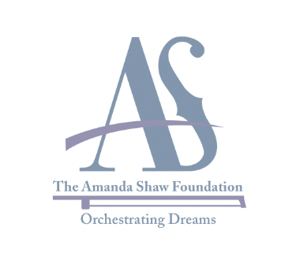

THE AMANDA SHAW FOUNDATION ORCHESTRATING DREAMS FUND SCHOLARSHIP APPLICATION

PERSONAL INFORMATION
Date:
Name:
Local Address:
City: State: Zip:
Home phone: Cell phone:
Email:
Birth Date:
Circle one: Male Female

Please use a separate sheet of paper to provide the information requested below:

List any noteworthy achievements, awards and/or recognition that you have received during your school career. Also, include any extracurricular activities which you participate in at school that you consider important.

Provide a list of community and personal activities along with any special talent that would set you apart from other candidates.

FAMILY INFORMATION

Father’s Name:
Address:
City: State: Zip:

His employer:

Mother’s Name:
Address:
City: State: Zip:

Her employer:

NARRATIVE

Please provide a narrative (no more than 750 words) to include the following:

- Describe financial need;
- Why do you feel deserving of this funding;
- Why are you passionate about the program/event you participate in;
- Describe the program/event, to include background of the organization/company providing the program/event you are requesting funds to participate in or are interested in participating in.

CERTIFICATION
We hereby certify that the information given in this application and in all attachments thereto is true, correct and complete to the best of our knowledge. We authorize the Amanda Shaw Foundation Orchestrating Dreams Scholarship Advisory Committee to verify all facts provided in this application.

Applicant’s Signature ______________________________________ Date _______________

Parent’s Signature________________________ Date_________ (applicant’s younger than 18)

IMPORTANT

Please make sure your application includes the following:
- Official academic transcript;
- Narrative;
- A phone or skype interview will be scheduled with selection committee

Please send complete application to:

The Amanda Shaw Foundation
Orchestrating Dreams Scholarship Fund
807 North Columbia Street, Covington, LA 70433
Email: cmouton@northshorefoundation.org

