ATTACHMENT “4”
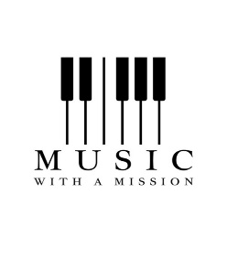
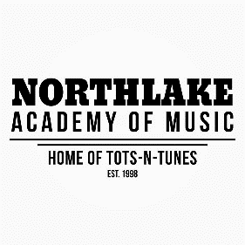

Music with a Mission Scholarship Application

History and Purpose: The Music With A Mission Fund was created in 2018 in collaboration with the Northshore Community Foundation to offer music scholarships to individuals with financial need and/or special needs in our community. The scholarship will support suitable music lessons and/or a music program to enrich lives. The music scholarship will be awarded for choir, private music lessons, and up to 2 semesters for Tunes Together and Tots-N-Tunes.

Music scholarships to be used toward tuition at Northlake Music Academy located at 1713 N. Causeway Blvd., Mandeville, LA 70471. The recipients are to be selected by an independent Scholarship Advisory Committee that is appointed by the Foundation.

CRITERIA
In making its decision, the Scholarship Advisory Committee will use the following criteria:

- Resident of St. Tammany and Orleans parishes;
- Ages 6 months to adulthood;
- Preference shall be given to those with special needs and/or financial need;
- Candidate’s involvement in volunteering in the community;
- Candidate should have an interest in music or voice.

GUIDELINES
Each applicant must submit an application to the Scholarship Advisory Committee by November 30th to include the following:

- The completed application form (APPLICATION DEADLINE IS FRIDAY, NOVEMBER 30, 2018);

The scholarship will be awarded as follows:

- One-time annually valued at $535 for Choir;
- Private Music Lessons for 1 month up to 6 months valued up to $732;
- One or two semesters valued up to $390 for Tunes Together;
- One or two semesters valued up to $460 for Tots-N-Tunes

The recipient must continue to demonstrate good character. At the end of their lessons, the recipient will provide the Foundation with a narrative of the previous music lesson(s) and a description of why they need to continue the music scholarship. The Scholarship Advisory Committee will review the recipient’s materials to consider awarding a continued music scholarship.

DEADLINE TO SUBMIT APPLICATION IS NOVEMBER 30, 2018

***Past recipients are allowed to re-apply for scholarships. The scholarship committee will interview applicants prior to awarding the scholarship.***

Please mail or email completed applications for this scholarship to:

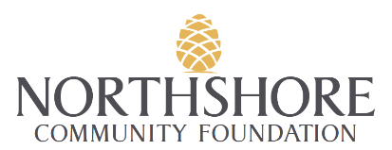

Music With A Mission Scholarship Advisory Committee
c/o Northshore Community Foundation
807 North Columbia Street
Covington, LA 70433
Carla Mouton: cmouton@northshorefoundation.org

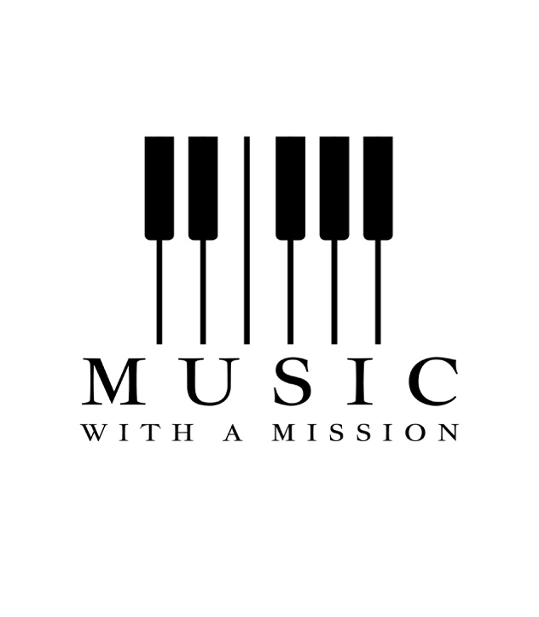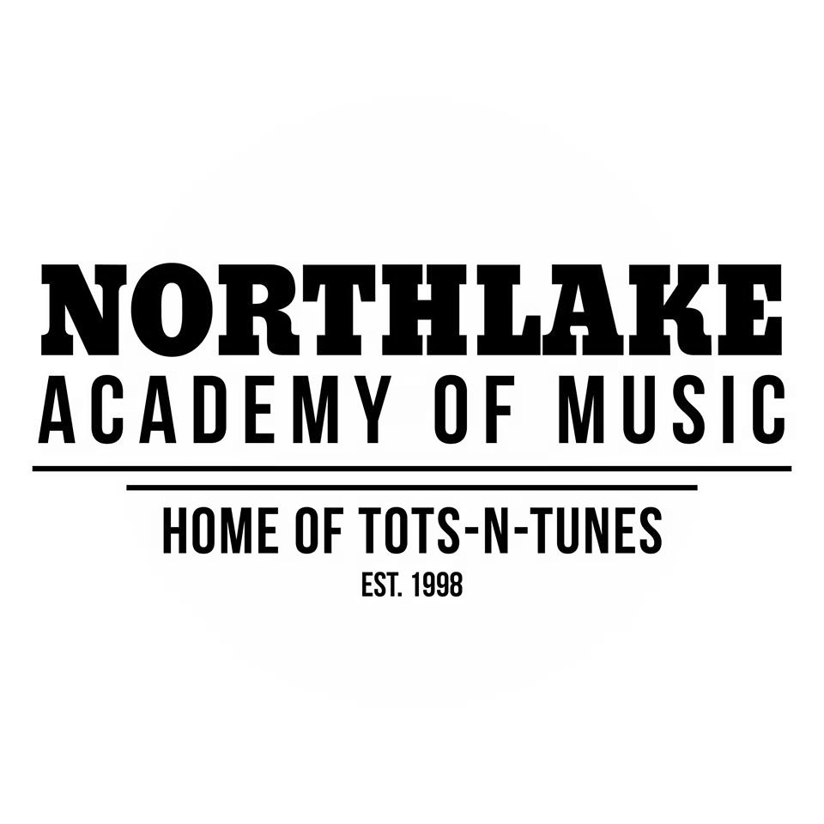

Music Scholarship Application

Applicant’s Name: ____________________________________

Date of Application: _____________________

APPLICATION DEADLINE: FRIDAY, NOVEMBER 30, 2018

Applicant’s Name: _________________________________________

Age:___________ Email: ______________________________
Mailing Address: ______________________________________________________________

_______________________________________________________________

Mother’s Name: _____________________ Phone: __________________________

Father’s Name: ______________________ Phone: __________________________

Applicant’s School:_____________________________________________________

Grade: _____________ GPA: _________________

TYPE OF SCHOLARSHIP

Please circle the type of music scholarship you are applying:

Choir Private Music Lessons Tunes Together Tots-N-Tunes

Special Achievements/Awards: _____________________________________________________________________

______________________________________________________________________

______________________________________________________________________

Extracurricular Activities:

___________________________________________Years Involved: _____________

___________________________________________Years Involved: _____________

___________________________________________Years Involved: _____________

___________________________________________Years Involved: ____________

___________________________________________Years Involved: _____________

Music Background/Experience:

Please list any music courses, lessons, or choirs you have been involved in and for how many years.

___________________________________________Years Involved: ______________

___________________________________________Years Involved:______________

___________________________________________Years Involved: ______________

Special Talents/Hobbies: ______________________________________________________________________

______________________________________________________________________

Work Experience:

Employer: _______________________________ Job Title: ________________________ Years: ______

Employer: _______________________________ Job Title: ________________________ Years: ______

Community Involvement:

Any services hours or special involvement outreaching to the community? Please explain in detail below:

______________________________________________________________________

______________________________________________________________________

______________________________________________________________________

______________________________________________________________________

Please explain in detail why you feel you should receive a music scholarship and what type of music lessons and/or choir program you are interested in.

______________________________________________________________________

______________________________________________________________________

______________________________________________________________________

______________________________________________________________________

______________________________________________________________________

Please explain in detail your financial need:

______________________________________________________________________

______________________________________________________________________

______________________________________________________________________

______________________________________________________________________

______________________________________________________________________

***Past recipients are allowed to re-apply for scholarships. The scholarship committee will interview applicants prior to awarding scholarships.***

CERTIFICATION
We hereby certify that the information given in this application and in all attachments thereto is true, correct and complete to the best of our knowledge. We authorize the Music With A Mission Scholarship Fund Advisory Committee to verify any and all facts provided in this application.

Applicant's Signature:____ ____________________ Date: ____________________

Parents Signature: ___________________________ Date: ___________________
(for applicants under 18 years of age)

THE DEADLINE FOR SCHOLARSHIP APPLICATIONS IS NOVEMBER 30, 2018

INTERVIEW: Applicant will be contacted to schedule a personal interview in January 2019.

***Past recipients are allowed to re-apply for scholarships. The scholarship committee will interview applicants prior to awarding the scholarship.***

Please mail or email completed application on or before November 30, 2018:

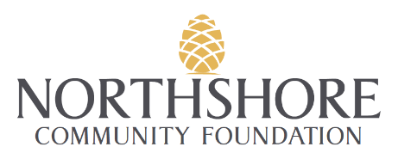

Northshore Community Foundation
c/o Music With A Mission Scholarship Advisory Committee
807 North Columbia Street, Covington, LA 70433
Carla Mouton: cmouton@northshorefoundation.org

