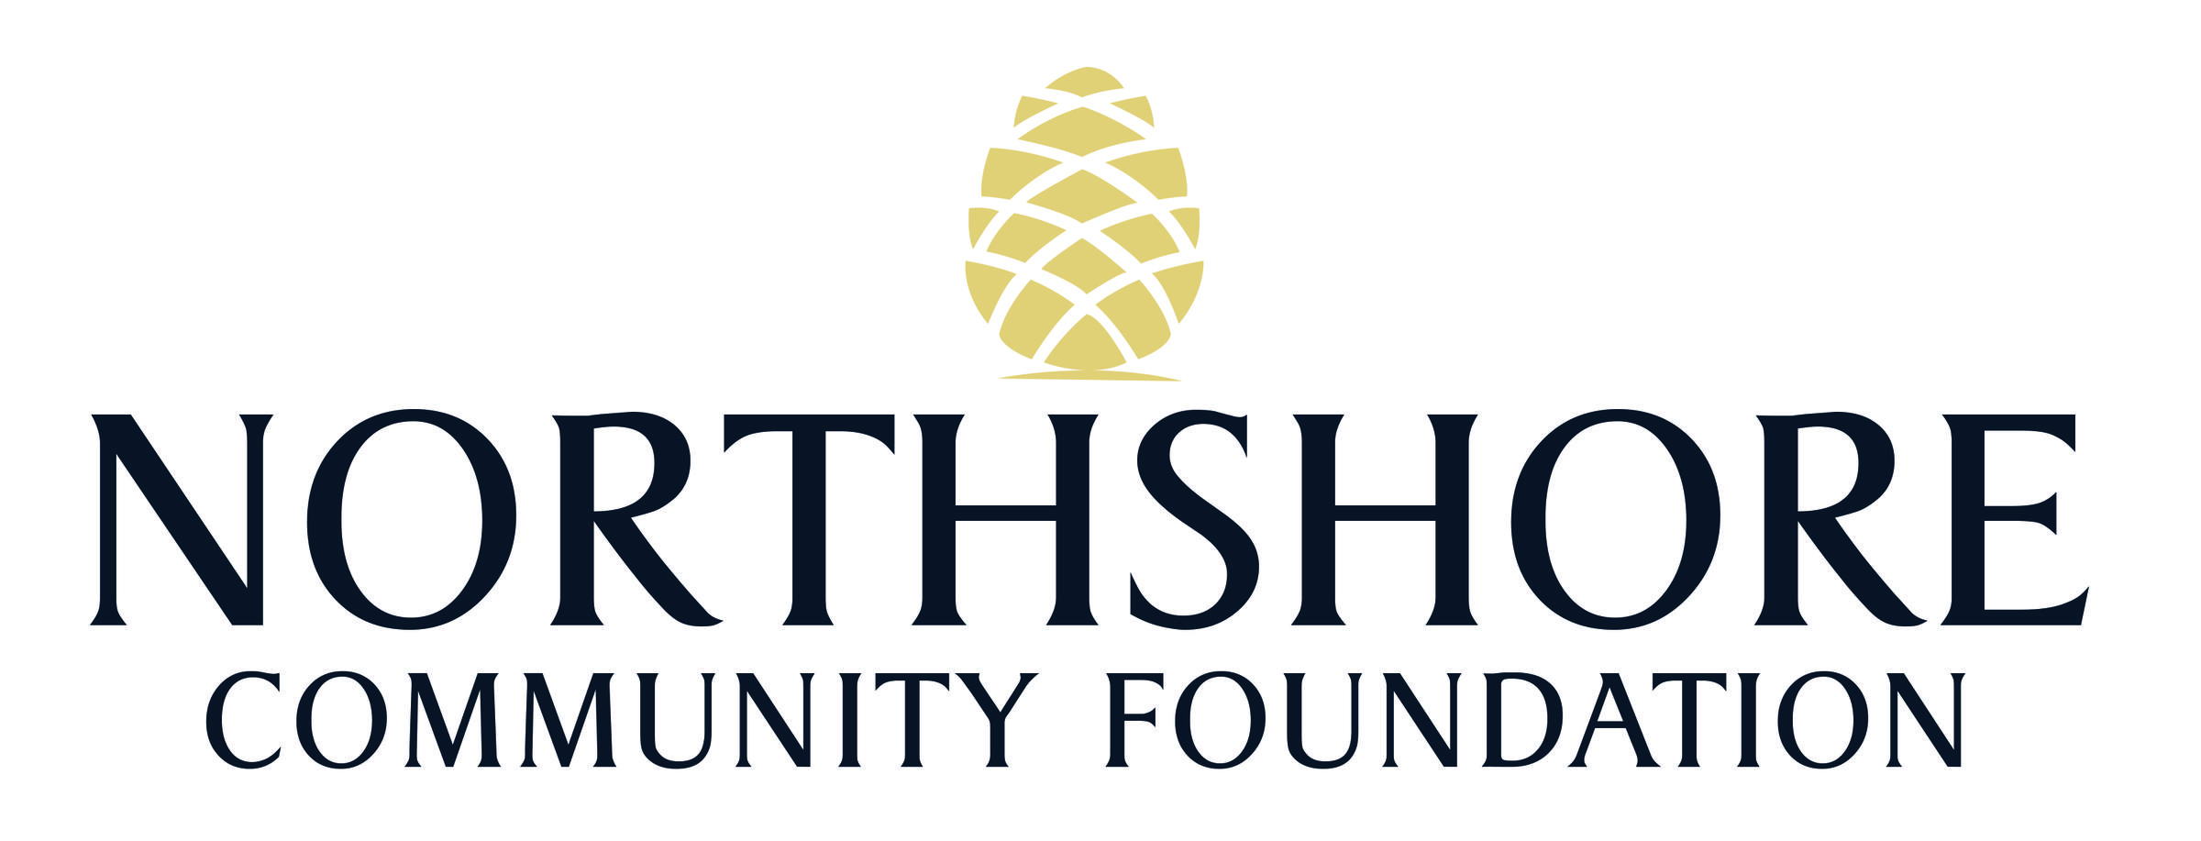
Innovation Partnership Grant Procedure
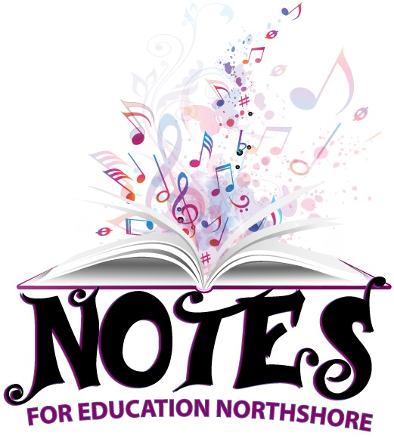

What Notes for Education Northshore Donates

Notes for Education Northshore awards instruments and equipment to eligible music instruction programs. These items are lightly used, blemished or otherwise imperfect and have been collected from manufacturers, retailers and previous owners. Descriptions regarding the specific imperfections of each instrument will be available to selected programs.
The organization is currently awarding acoustic guitars, electric guitars, acoustic-electric guitars, bass guitars and the equipment necessary to play these instruments. However, other traditional music instruments are sometimes available. Traditional instruments include string instruments, woodwind instruments, brass instruments, percussion instruments, keyboards and voice. DJ equipment and computers are not available through Notes for Education Northshore.

Grant Eligibility Criteria
Notes for Education Northshore awards traditional instruments to public and/or private schools on the Northshore. To qualify as a music instruction program, participants must be learning how to make music. Participants can be of any age. However, music appreciation or entertainment programs do not qualify, and the participants cannot be professional or career musicians. Schools that meet the following guidelines are eligible for consideration of a grant as part of Notes for Education Northshore’s strategic parish-wide plan:

A qualified program must fit into one of these categories:

- In-school music classes, in which the students make music
- School must serve a minimum of 65% economically disadvantaged students
- After-school music programs that are not run by the school
- School must have an established instrumental music program that is offered during the regular school day; all types of instrumental programs qualify (i.e. band, strings, mariachi, guitar labs, keyboard labs, jazz band, modern band, etc.)
- School must be able to provided a list of existing instruments inventory
- School must have a dedicated instrumental music room with adequate and secure storage for musical instruments.

Innovation Partnership Grant Procedure

In addition, the program must meet the following five criteria:
- Individuals are not denied participation based on their musical abilities.
- Each program participant receives music instruction at least once a week for at least eight months per year. (Camps and workshops are not eligible.)
- With or without a grant from Notes for Education Northshore, the organization is confident that the program will exist for the foreseeable future.

Instrument Grant Application Instructions
Please review Notes for Education Northshore grant eligibility criteria listed above before applying.
Incomplete applications will not be considered. You may email your grant application to cmouton@northshorefoundation.org Please be sure to include your organization in the “subject” line. You will need to include the following:
- Grant Application
- Completed and signed Grant_Agreement_Form
  - This form must be signed by the organization’s executive director or school principal and the program’s music instructor
- One program photo that captures the spirit of the program

All applicants will be evaluated solely based on the information provided in the Grant Form. DEADLINE for 1st Cycle: Friday, January 31, 2020. Applications are approved on a rolling basis that fluctuates depending on the amount of inventory in stock.

How Instruments are Distributed
If your program is selected, Notes for Education Northshore will contact you. Please note that it will take several weeks or more to process your application.

Innovation Partnership Grant Procedure

GRANT APPLICATION

Date:

Name of nonprofit or school (Nonprofit organizations should provide the name that appears on their tax exempt letter):

If the organization is a nonprofit, what is its EIN? If the organization is a public school, what is the name of the principal?

Name of program that will utilize the requested instrument(s):

Location of program (The city or geographical region):

Contact person(s): Email address: Cell phone number(s):

Program or organization website/social media:

In 200 words or less describe your program.

How long has your program been functioning? (Circle One)
Less than a year 1-3 years 3-5 years More than 5 years
Innovation Partnership Grant Procedure

Does your program require participants to audition? (Circle One)
Yes No
If you answered “Yes” to the previous question, do the results of this audition affect who is chosen for participation in the program? If you answered “No” you may skip this question.

How many times per week do participants receive music instruction? (Circle One)
Our program does not provide weekly instruction 1-3 times 4 or more times
How many months out of the year does your program operate? (Circle One)

1 month 1 summer 1 semester 1 school year 1 calendar year

Describe any awards, accomplishments, etc. and why we should choose your program (you may attached another piece of paper)

What is the total operating budget? $ (Please attach a copy of the program budget).

On a scale of 1 to 10, how confident are you in the sustainability of your program’s funding streams (donations, fundraising, sales, etc.)? (Circle One)
1 2 3 4 5 6 7 8 9 10
What kind of instruments do you plan to request on behalf of your organization?

Is the information you have provided in this form accurate to the best of your knowledge?

Innovation Partnership Grant Procedure

GRANT AGREEMENT

I hereby attest that all information provided to Notes for Education Northshore during the application process is accurate to the best of my knowledge.
If the organization I am representing is awarded a grant from Notes for Education Northshore, the items should be shipped to the following address:
STREET:
CITY, STATE ZIP:
If the above address is that of a public school, Notes for Education Northshore should take the following action if the items are ready for shipping while school is not in session:

If the organization I am representing is selected, I also agree to send the following to Notes for Education Northshore (slidelljazzandblues@gmail.com) no more than six months after receiving the grant:
- High resolution photos (preferably digital) of the program, showing use of the grant.
- A testimonial from someone in the program who was affected by this grant.
- A statement addressing the following questions:
  - How many people were served by this grant?
  - What has been the peripheral impact of this grant?
  - Provide evidence of award announcement on website/social media sites.
I understand that I am responsible for returning any awarded instruments or equipment to Notes for Education Northshore if the applicant program is terminated or is no longer is use by the student body so that they may be sent to other needy programs.
I understand that I may not under any circumstances sell any awarded instruments or equipment. Furthermore, I understand that any violation of this policy will result in the revocation of current and future grant privileges.
I hereby grant permission and license to Notes for Education Northshore to use the following in connection with its promotional materials (including print, websites and any other medium):
- The name and logo of the program, organization, and/or school.
Innovation Partnership Grant Procedure

- All photos the organization/school submits to Notes for Education Northshore.
- All statements and information the applicant organization supplies to Notes for Education Northshore from all sources (including all content previously submitted, content that will be submitted in the future as well as verbal statements.)
- If this organization is selected to receive instruments, I agree to post an image celebrating this honor to our program or organization’s website and social media sites.
- % of economically disadvantaged students/population

I hereby affirm that I have read, understand and agree to the provisions set forth in this Agreement Form on behalf of .
(name of organization/school)

Organization’s Executive Director, CEO or school’s Principal
Signature: Date:
Printed Name:

Program’s Director/Music Teacher
Signature: Date:
Printed Name:

